**Lab-W12**

**Curve and surface**

**NIM/Name:**

**Date:**

See <http://www.glprogramming.com/red/chapter12.html>

1. Modify the lab 12-1 so that you **add another point in the curve**. For example:

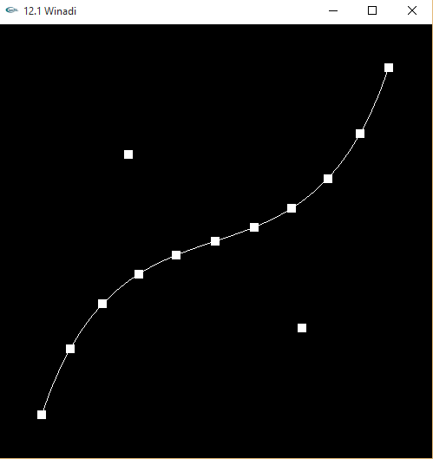

1. Modify of control point on lab 12-2. **Create a new shape of surface**. For example:

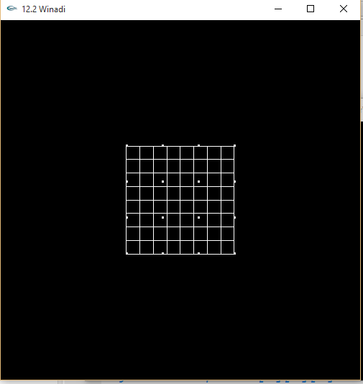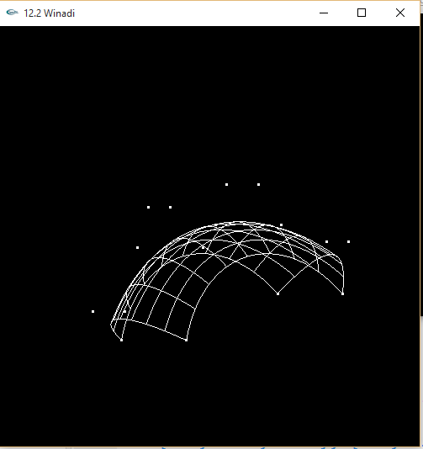

1. **Screenshot the result of the programs (12-1.…12-6) into Result (picture column),** give a name of them using glutCreateWindow(“12-1 Your Name here”);
2. **Describe the difference of each program in the table**

Example 1: 12-1 and 12-2. How to writing the code for create curve and surface using Bezier curve

Example 2: 12-2 and 12-3. How to use shading on surface, and how to coloring (12-4) the surface on 12-3.

**What to Submit:**

1. This .docx file with filename **lab12-NIM-NAME.docx**

2. **12-1-YOURNAME.cpp**

3. **12-2-YOURNAME.cpp**

|  |  |  |
| --- | --- | --- |
| **No** | **Result (picture)** | **Describe the goal and the differs of the code** |
| **12-1** |  | The code is to specified each line with a point so it can draw more accuretly. The differ is adding drawing loop with draw as GL_POINTS AND GL_LINES |
| **12-2** |  | This just need change the rotation to 0 degree. And the second picture we just need to change the control point to a different vertex. |
| **12-3** |  | Menambahkan efek glowing dengan ada diffuse, ambient, shiniess |
| **12-4** |  | Sama seperti no (2)  Menambahkan efek glowing dengan ada diffuse, ambient, shiniess |
| **12-5** |  | Membuat efek glowing dan timbul |
| **12-6** |  | Membuat efek glowing dan timbul |